Set Up Dog Shelter Database: CREATE DATABASE

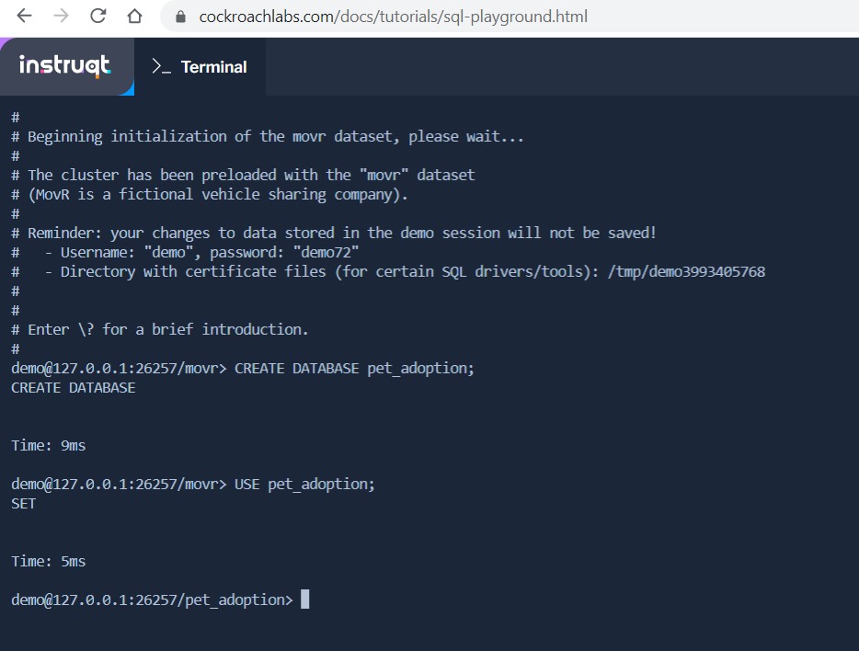

Table #1: A Table for Animals: CREATE TABLE & UUID

Table #2: The List of Adoptions: TIMESTAMP

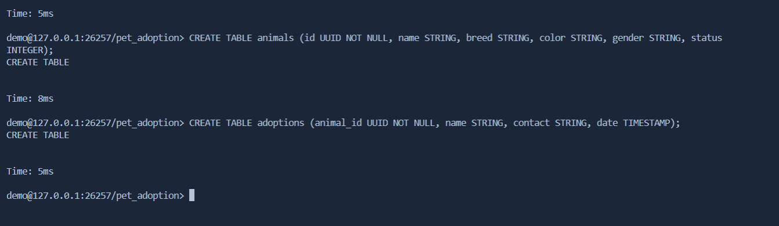

Verify Database Setup: SHOW TABLES & COLUMNS

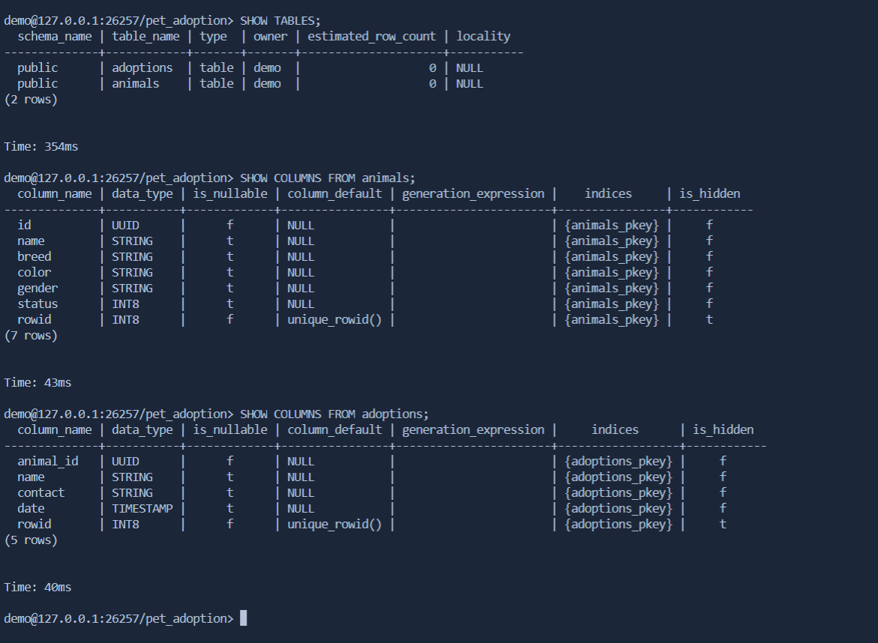

Add Dogs to Database: INSERT

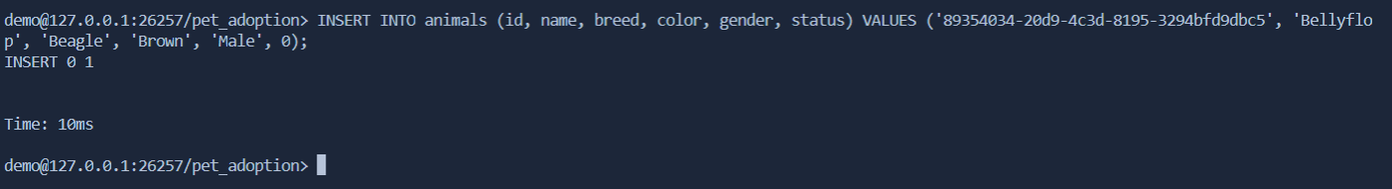

Retrieve List of Dogs: SELECT \* FROM

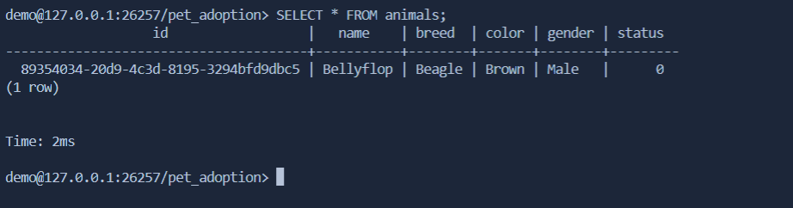

SELECT breed FROM animals;

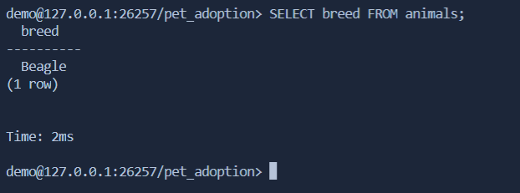

SELECT name FROM animals WHERE gender = 'Female';

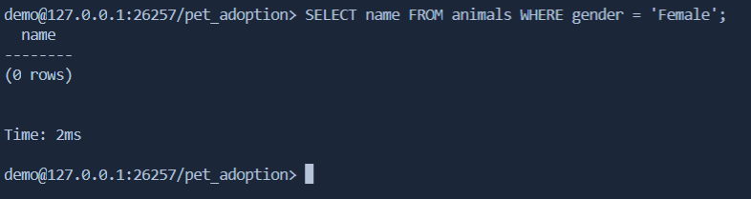

SELECT id FROM animals WHERE status = 0;

